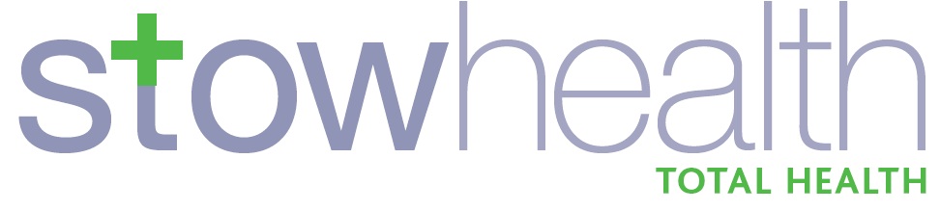
COMPLAINT FORM

We are sorry that you are not satisfied with the service that you have received at Stowhealth. Please complete this form with as many details as possible about your complaint – we will respond to you as soon as possible and try to resolve the problem.

Your details
Name: __________________________________________________

Address: __________________________________________________

__________________________________________________

Post Code: _________________ Tel. No: _________________

Date of Birth: _________________ Usual GP: _______________________

Patient’s details (if different from above)

Name: __________________________________________________

Address: __________________________________________________

__________________________________________________

Post Code: _________________ Tel. No: _________________

Date of Birth: _________________ Usual GP: _______________________

Details of complaint (including date(s) of events and persons involved)

Complainant’s signature:________________________ Date: ____________
Complaint continued:

Complainant’s signature:________________________ Date: ____________

COMPLAINT FORM
Patient Authority to Disclose Information

Where the complainant is not the patient:

I ________________________________________________ (name in block capitals please) authorise the complaint set out overleaf made on my behalf by

________________________________________________ (name in block capitals please) and I agree that the practice may disclose to that person / organisation (only in so far as is necessary to answer the complaint) confidential information about me which I provided to them. This authorisation can be checked if necessary.

Patient’s signature: _________________________________

Date: _________________________________

Name and address: _____________________________________________

______________________________________________________________

______________________________________________________________

WE OPERATE A PRACTICE COMPLAINTS PROCEDURE AS PART OF THE NHS SYSTEM FOR DEALING WITH COMPLAINTS. OUR SYSTEM MEETS NATIONAL CRITERIA.

OUR PRACTICE COMPLAINTS LEAFLET GIVES DETAILS OF THE PROCEDURE AND IS AVAILABLE FROM RECEPTION.

OUR AIM IS TO GIVE YOU THE HIGHEST POSSIBLE STANDARD OF SERVICE AND WE TRY TO DEAL SWIFTLY WITH ANY PROBLEMS THAT MAY OCCUR.

HELP US TO HELP YOU.

Action/Summary Sheet (Internal Use only)

Complainant: ___________________________________________

Patient’s GP: ___________________________________________
Patient (if different):
___________________________________________

Address: ___________________________________________

___________________________________________

___________________________________________

___________________________________________

GP(s)/staff member(s) involved:

___________________________________________

Date complaint received:____________ Date acknowledged:_____________
telephone/in person/letter

Brief details of complaint:

Meeting held (date): ___________________________________

Letter of explanation sent (date): ___________________________________

Brief details of response:

Investigation completed within 10 working days? Yes/No

Reason why, if not: ___________________________________________

Critical Incident No: ________________

